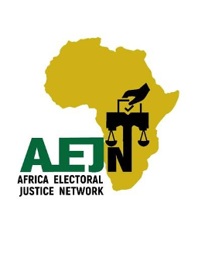
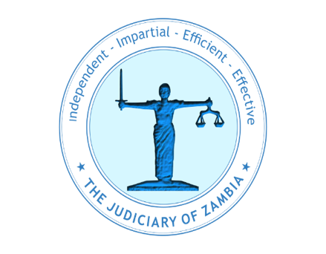
______________________________________________________________________________
Communique
of the 4th Africa Electoral Justice Network Conference
Livingstone, Zambia 9-13 September 2025
___________________________________________________________________________
1.0 Background
1.1 The Africa Electoral Justice Network (AEJN) is a regional forum that brings together judges who adjudicate electoral disputes in Courts and Tribunals, and Electoral Management Bodies (EMBs), electoral justice practitioners and experts, and civil society organizations across the African continent.
1.2 The AEJN aims to serve as a pan-African knowledge hub for African Countries in matters of electoral justice.
1.3 From 9 -13 September 2025, the AEJN, in collaboration with the Judiciary of the Republic of Zambia, the Africa Judges and Jurists Forum (AJJF), the South Africa Judicial Education Institute (SAJEI), the Southern and Eastern Africa Chief Justices’ Forum (SEACJF), Yiaga Africa and the Kenyan Section of the International Commission of Jurists (ICJ Kenya) held its 4th Annual Conference in Livingstone, Zambia under the theme Reflecting on Past Electoral Dispute Resolution in Africa: Charting the Future of Electoral Justice in the Age of AI and ICTs
1.4 The Conference drew participants from judicial officers, electoral justice practitioners and experts, and civil society organisations from across Africa.
1.5 The Conference provided a crucial platform for dialogue on the challenges and opportunities in electoral dispute resolution, with a specific focus on the transformative impact of Artificial Intelligence (AI) and Information and Communication Technologies (ICTs).
1.6 This culminated in the validation for adoption by the AEJN of a Toolkit on Judicial Oversight on Artificial Intelligence in African Elections with the intention to contribute to the strengthening of electoral integrity in Africa in the era of new ICTs and Generative Artificial Intelligence.
2. Key Reflections and Challenges
2.1 The Conference noted and acknowledged that AI and ICTs are increasingly inevitably being resorted to and are being used in electoral processes, with a few African countries openly using AI at varying stages of the electoral cycle.
2.2 The Conference further noted that AI and ICTs are a necessary factor and inevitable component of electoral justice.
2.3 The Conference noted the potential of deepening trust and integrity of African elections through responsible and ethical adoption of AI in elections. It also considered the ability of AI to enhance electoral justice delivery.
2.4. The Conference identified challenges that have the potential to undermine the integrity and credibility of elections when AI and ICTs are employed irresponsibly in the electoral cycle as well as election dispute resolution mechanisms. These include but are not limited to: -
- The rise of AI and its associated challenges: The growing use of AI in political campaigns, election management and election dispute resolution presents both new opportunities and risks, from automated voter targeting to the potential for algorithmic bias in electoral processes. Some of the opportunities and risks yield a trust deficit in the electoral processes and impede efficient election logistics management. Other issues such as human interference and interface which may create biases and can be exploited to disadvantage certain groups from exercising their free will in choosing who to give authority to govern, potential electoral fraud, political repression and shrinking civic space which in turn impacts on the integrity of the electoral process and potentially impedes electoral justice.
- Resource Constraints and Other Capacity Gaps: The absence of resources to develop African-bred AI tools and a lack of specialized training for judges and lawyers in electoral law and technology-related disputes hinders electoral integrity.
- Technological Disruption: The misuse of AI and ICTs, including dis/mal/mis-information and cyber-attacks, pose a significant threat to electoral integrity.
- Absence of AI specific regulatory and policy frameworks: The absence of an AI specific regulatory framework has hindered the full and open adoption of AI in the electoral processes. In addition, there are no AI specific policy guidelines to assist judicial officers, electoral justice practitioners and experts in the use of AI in election dispute resolution.
- Absence of homegrown AI tools: There are currently very limited AI tools that speak to the African context hence the need to create and adopt systems that will ensure that electoral integrity is not compromised within the African setting.
3. Resolutions and Way Forward
The Conference adopted the following Resolutions to prepare for and guide the future of electoral justice in Africa in the wake of AI and ICTs:
  - Awareness Raising and Lobbying: The AEJN will embark on awareness raising and lobby for localised adoption and training of judicial officers and electoral practitioners on the Toolkit for Judicial Oversight of Artificial Intelligence in African Elections.

  - Specialised Training: AEJN commits to developing and implementing specialized training programs for judicial officers and election practitioners on electoral law, digital forensics, and the legal implications of AI and ICTs.

  - Judicial Decision Tracking: AEJN will design a framework for tracking, analyzing and reporting on judicial decisions on AI in elections. This will contribute to building a body of knowledge on judicial interventions on AI in elections.

  - Harmonising Legal Frameworks: AEJN resolves to advocate for the adoption by the AU and sub-regional bodies of policy guidelines and model laws on the use of AI and ICTs in electoral processes including electoral dispute resolution.

  - Embracing Technology Responsibly: The AEJN will work to develop a framework for the ethical and responsible use of AI and ICTs in elections. This includes advocating for laws that address disinformation and ensuring transparency in the use of these technologies.

  - Fostering Public Trust: AEJN will launch public education campaigns to inform citizens about the regulatory policy frameworks on the ethical and responsible use of AI and ICTs in elections to foster public trust.

  - Appointment of an Expert Panel to Develop Model AI and ICT Policy Frameworks: AEJN will appoint a specialist panel to assist the creation of model laws and policies on the use of AI and ICT in the electoral processes for purposes of use as a lobbying tool to various African judiciaries, governments as well as the AU and other sub-regional bodies.
4. A Call to Action
The members of the of the Africa Electoral Justice Network and the participants of the 4th Annual Conference of the AEJN, departed with a renewed sense of purpose, calling upon all stakeholders that is governments, judiciaries, civil society, and development partners - to embrace these resolutions and work collaboratively towards a future where every vote is counted, every voice is heard, and electoral justice is a reality for all Africans.

Dated and signed at Livingstone, Zambia, this 12th Day of September 2025



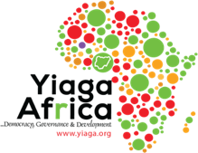
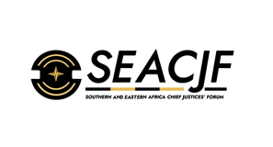


Justice Boissie Mbha Dr. Mumba Malila, SC AEJN CHAIRPERSON CHIEF JUSTICE OF ZAMBIA

